Filing a Sales Tax Return

Disclaimer
The information in this manual is for educational and informational purposes only and does not constitute legal advice. Information is presented as an overall review that is subject to law changes and may not apply to all states.
Information in this manual is believed to be accurate as of the date of publication. In the event that any information in this manual is later determined to be in error, this manual cannot be used by taxpayers in supporting a specific position or issue before the Department of Revenue, as it does not have the statutory or regulatory authority.

Filing a Sales Tax Return
(Updated 7/30/19)

The user will first need to login to their Kentucky Business One Stop Account.
- Go to www.onestop.ky.gov
- Click on the One Stop Business Services Icon.
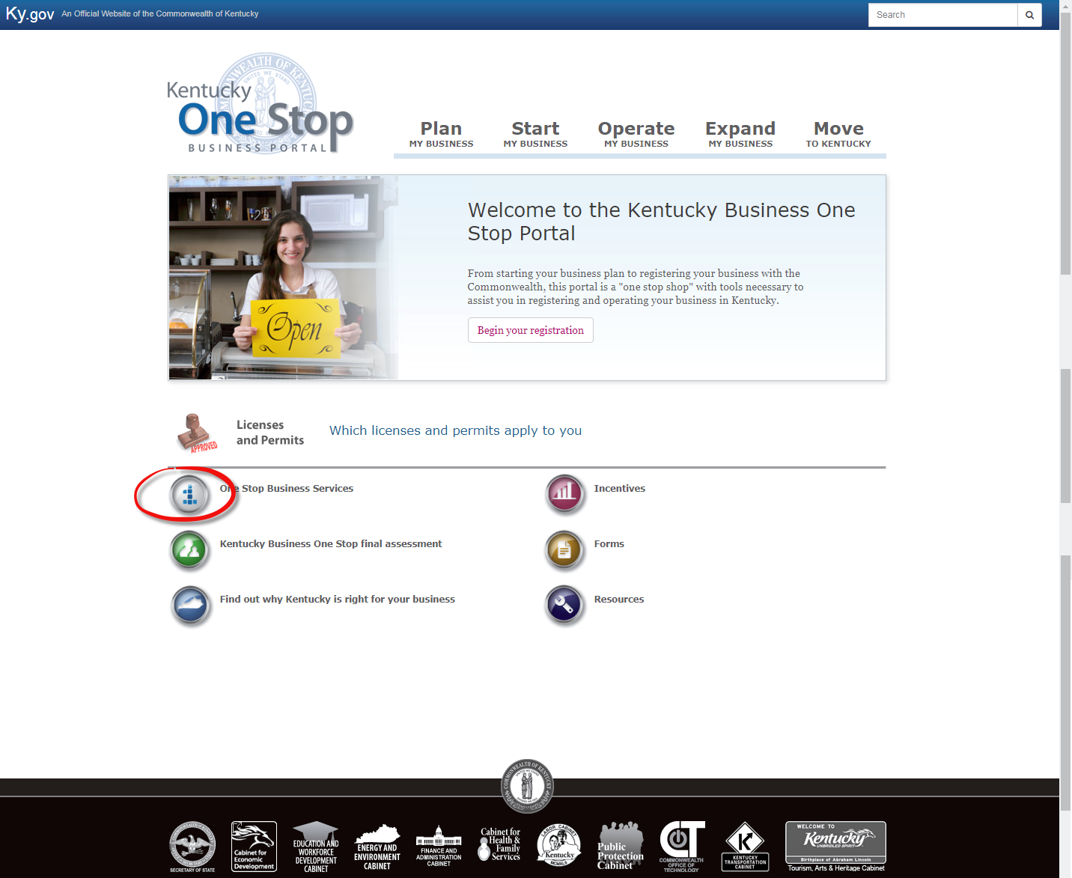

Next, type in the Email and Password and then click Sign in. If the user doesn’t have a KOG account set up, they will need to create one.

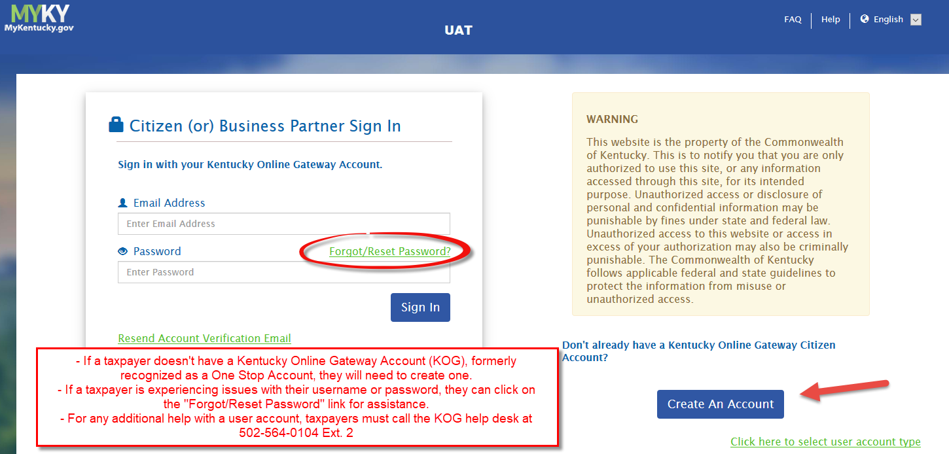

The user should then select the business. This is only for Sales, Consumers, URGL, Transient, Tire, and CMRS.

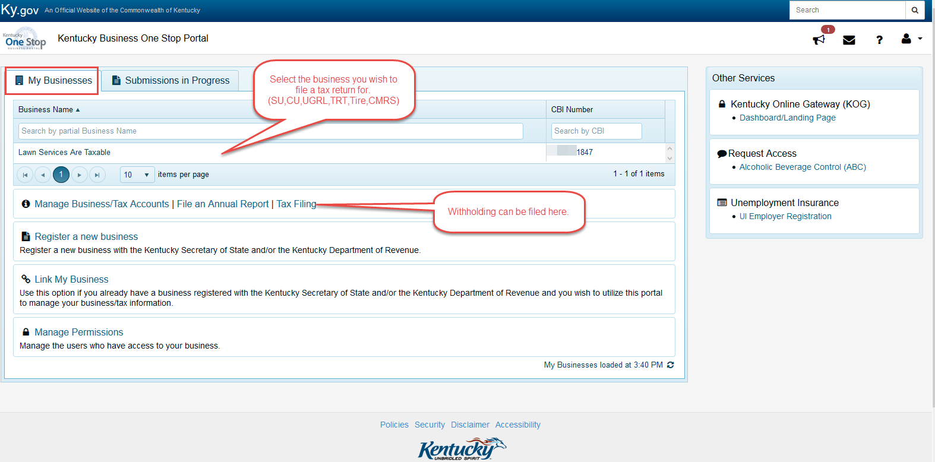

Select the File Taxes button.
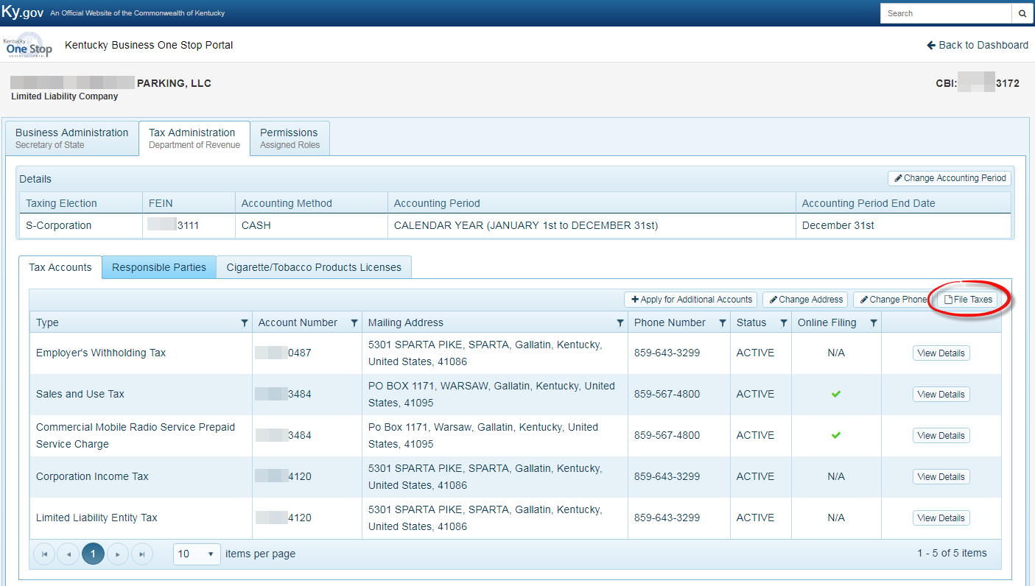

This will take them to the E-File screen. As you can see below, this account has access to one filing account. Click on the account number to file the return.

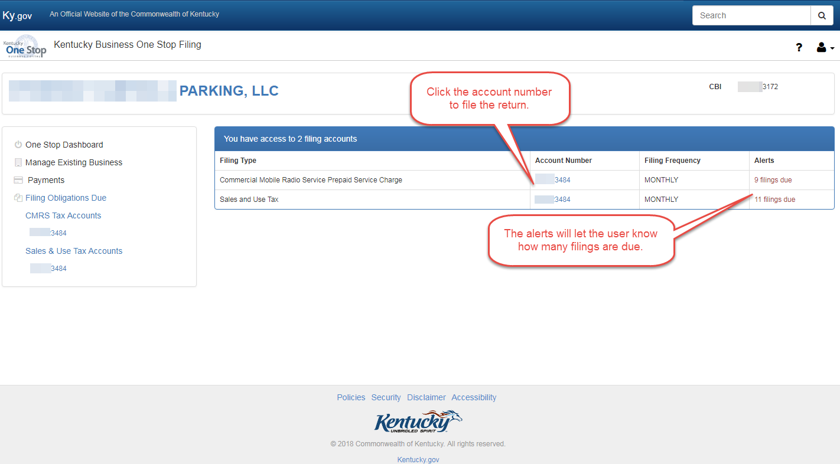
The user can select which period they wish to file, the top period being the most recent return due and the bottom the oldest.
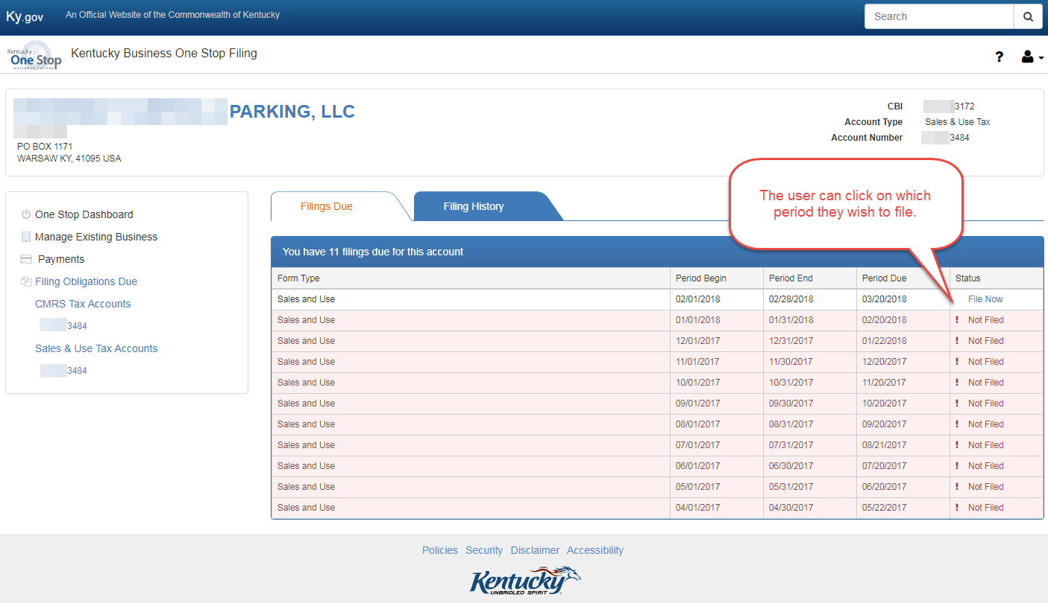
After the user selects the period they want to file, they will need to complete the return. If the period is late, penalties will be added but a note indicates to the user that there may be additional penalities and interest, which they will be billed for.
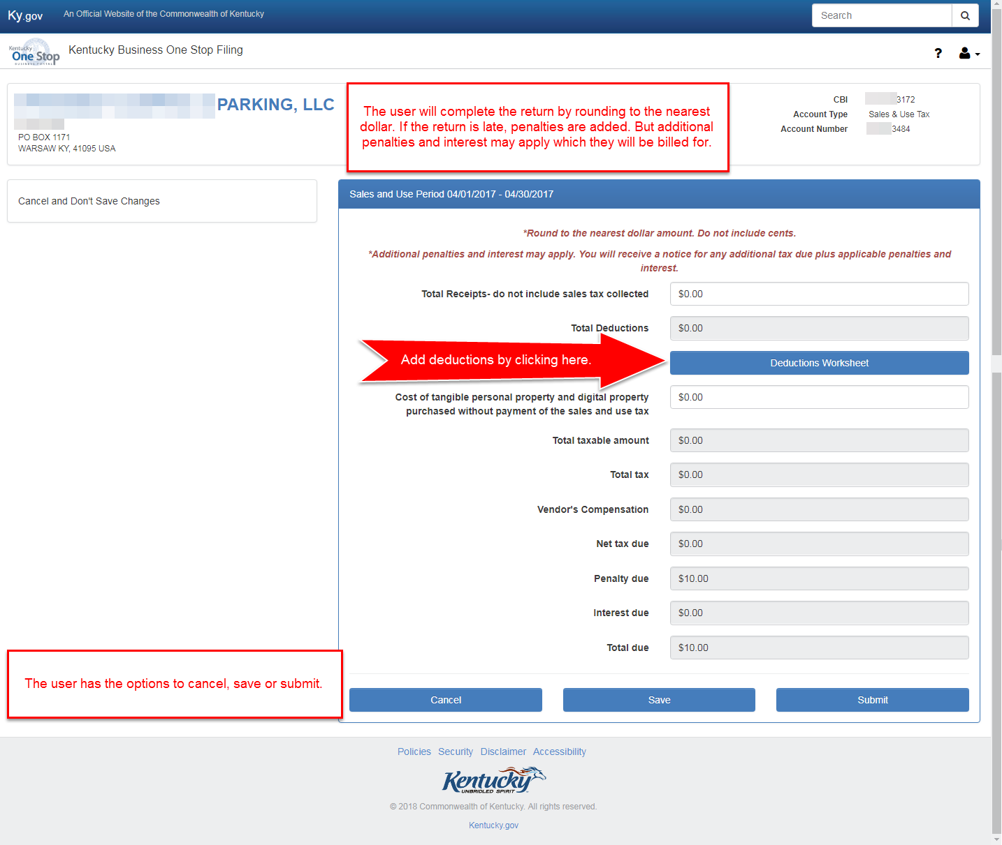

Once the user completes the returns and submits it, they will get an Electronic Signature pop up. It will ask them to Sign and submit the return.
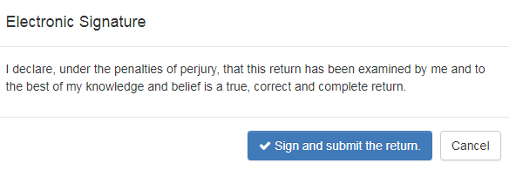
After the user signs and submits the return, they will have the option to Make a Payment, View and Print, or Continue to My Obligations. Make a Payment will take the user to EEPS where they can submit a payment for the return. View and Print allows the user to print off the return, and Continue to My Obligations takes the user back to the business’ Filings Due tab.
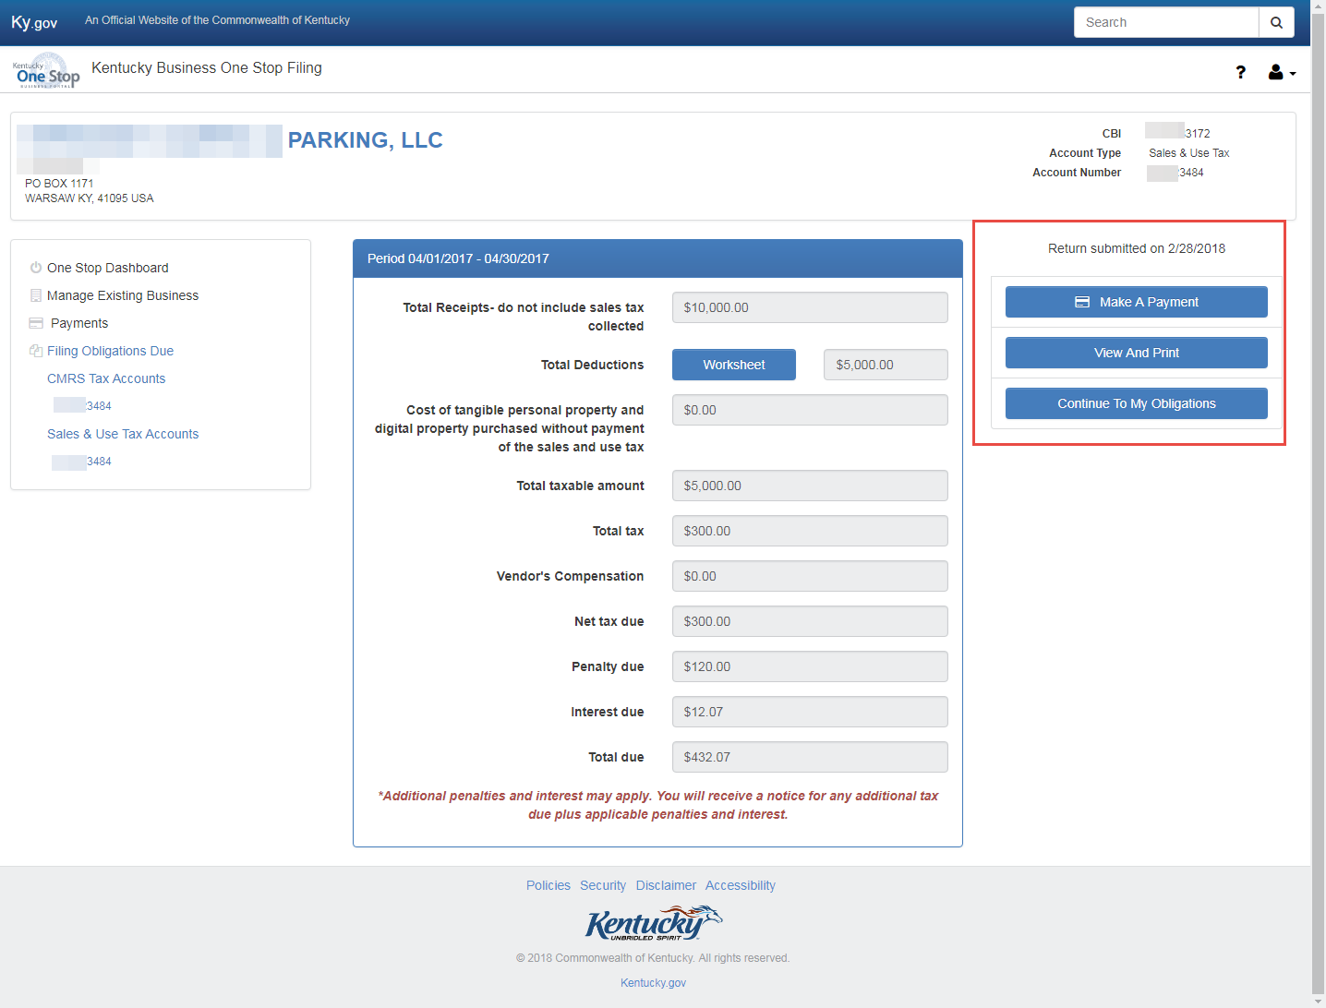

Making a Payment:
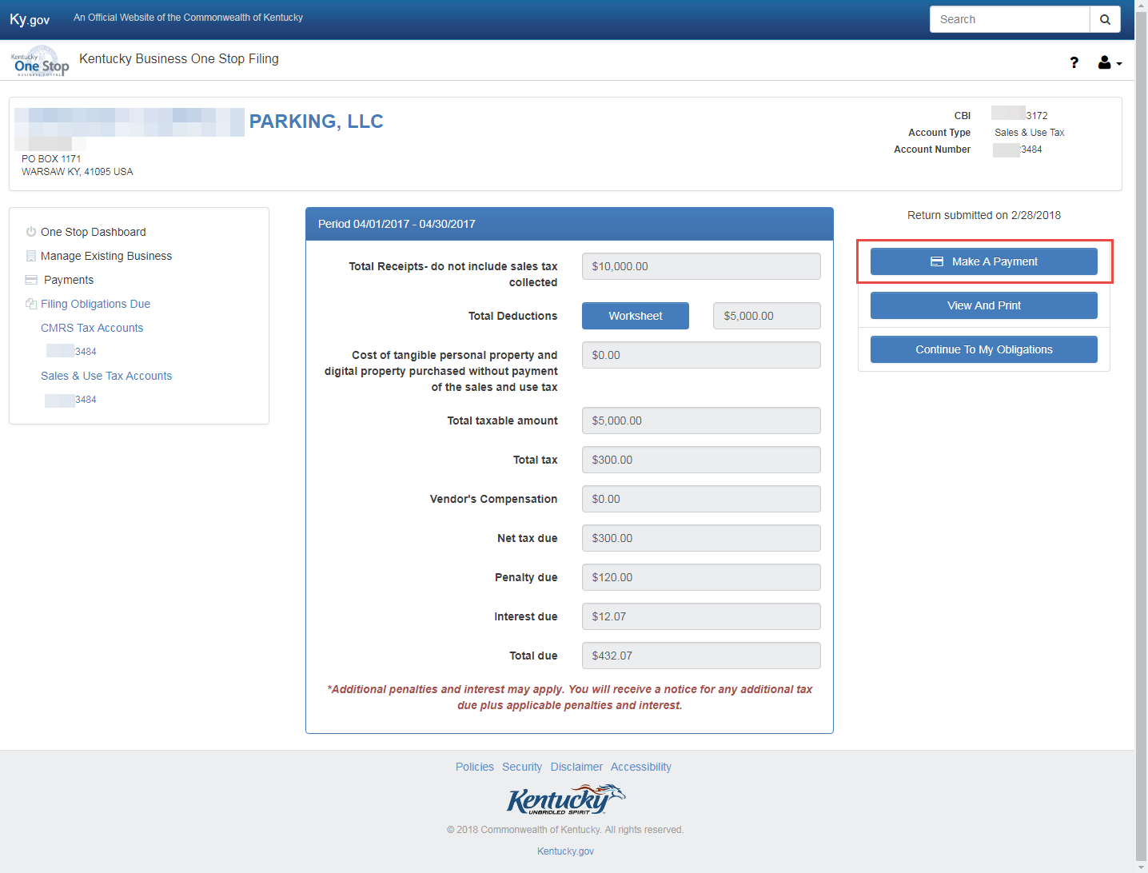

Once the user selects Make a Payment, they will be taken to the DOR’s webpage (EEPS). Their demographic and business information will pre-populate. Click Next to continue.

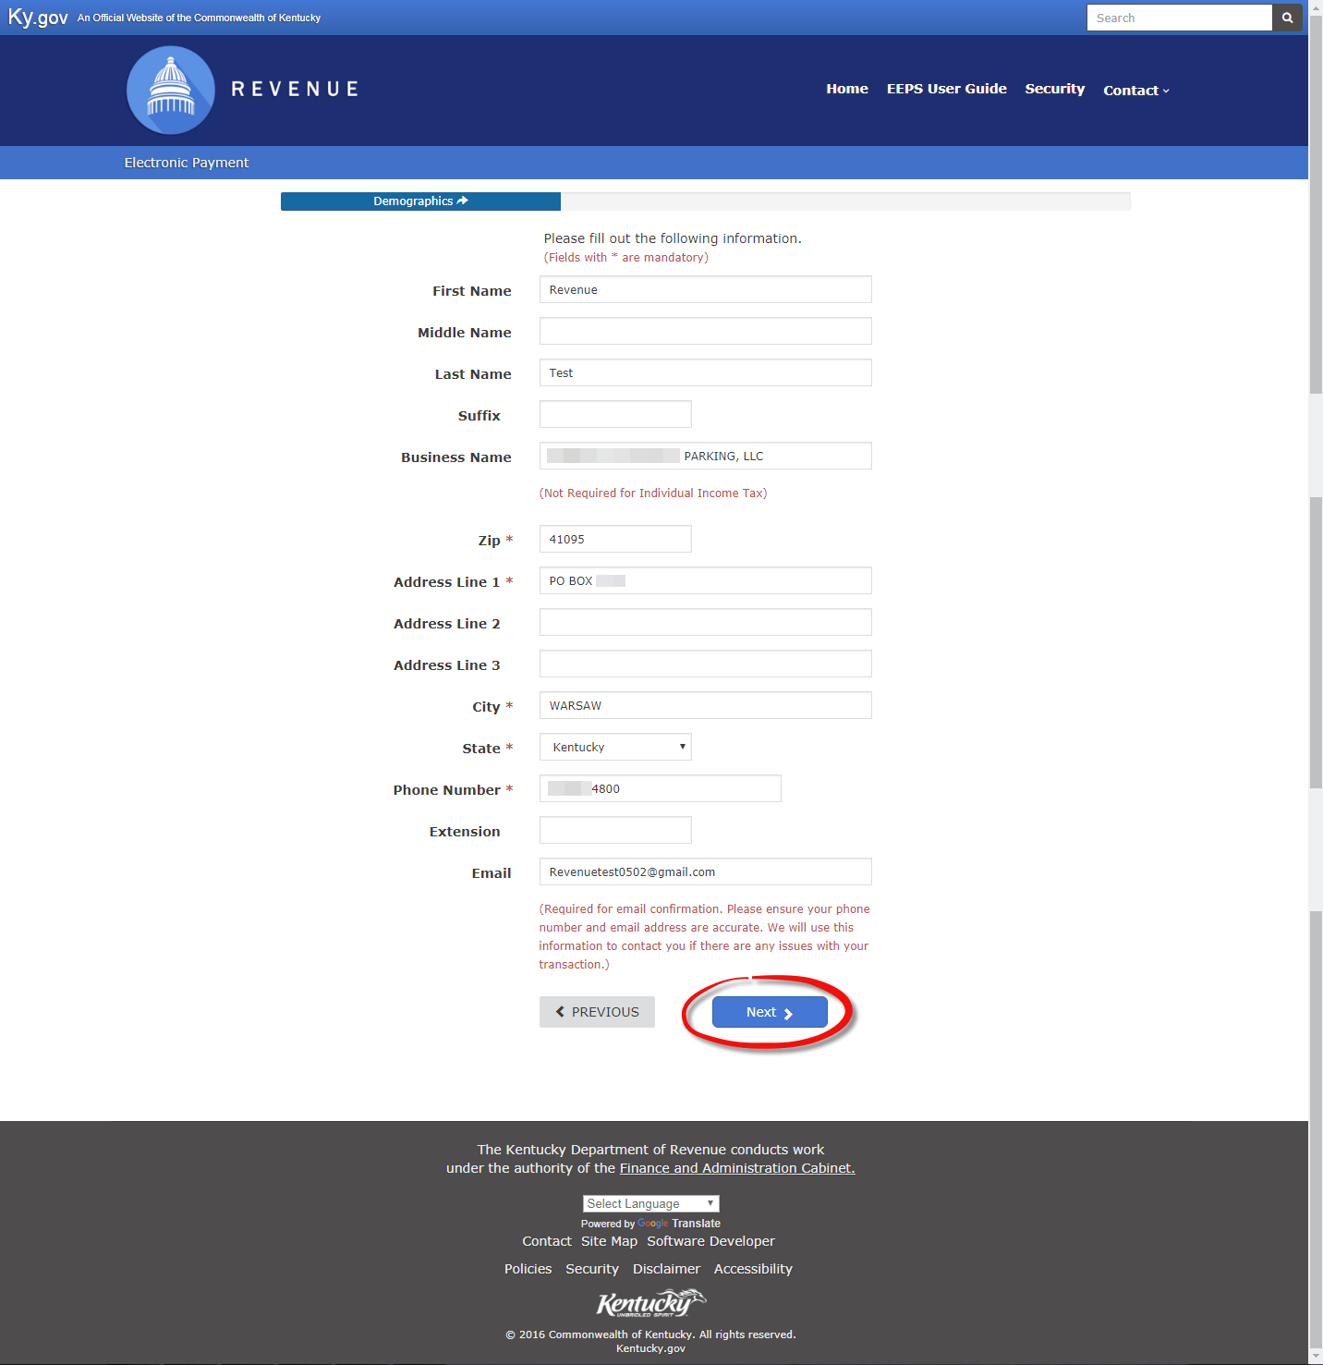

On the next page, the tax account number, type and period will pre-populate. The user will need to select the payment type from the drop down menu (ACH/Electronic Check or Credit/Debit card). Once the user selects which option they want to pay with, they will need to provide their payment information.
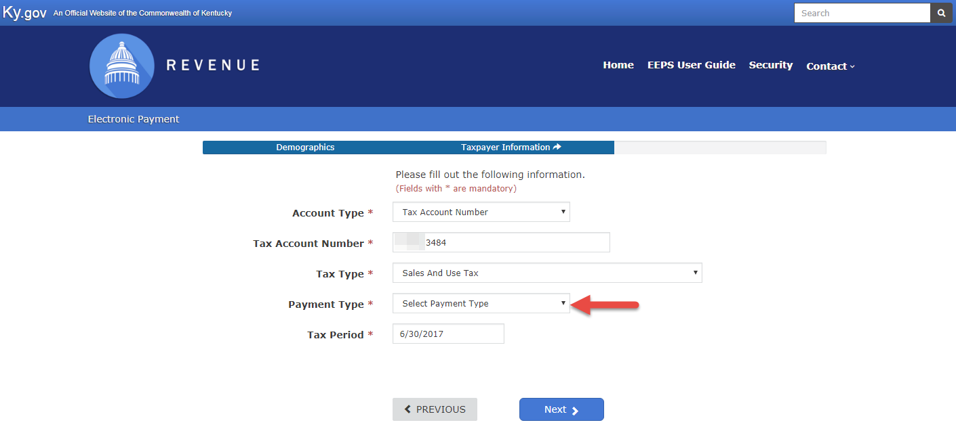
ACH/Electronic Check:
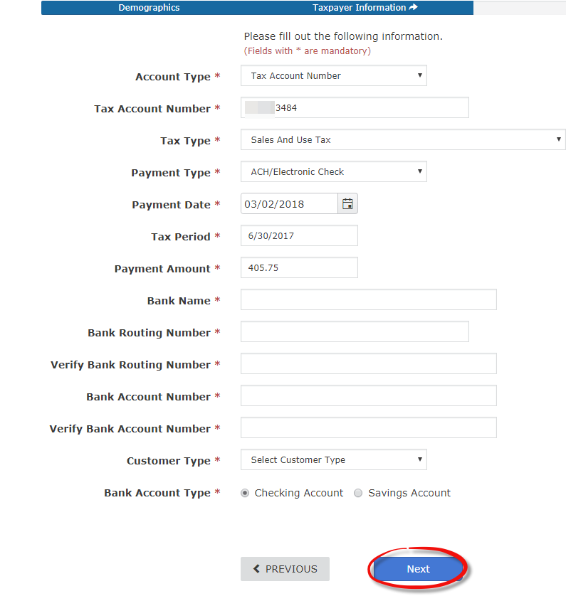

Credit: Debit Card
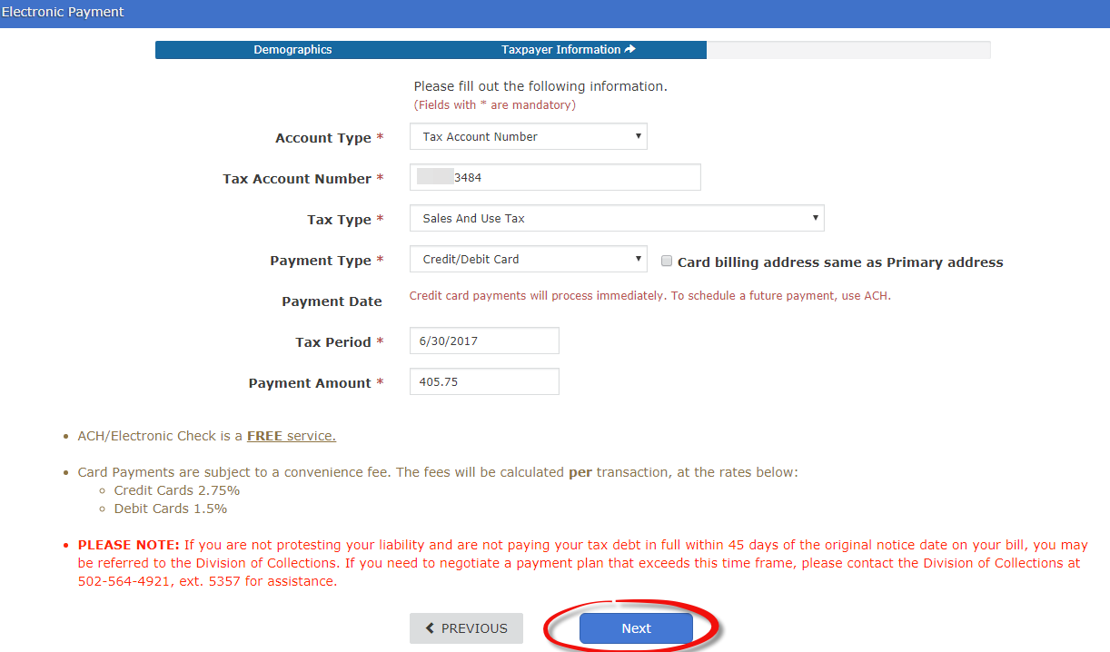
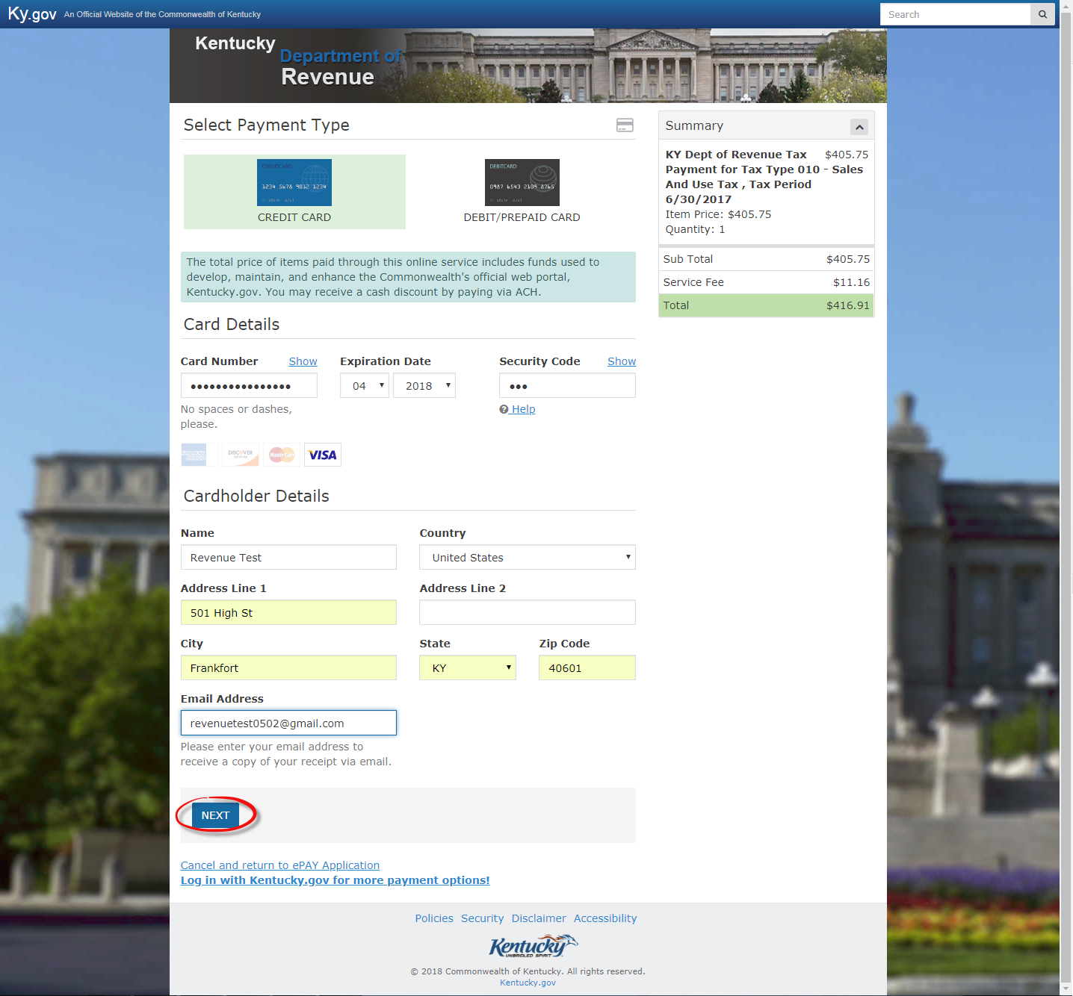
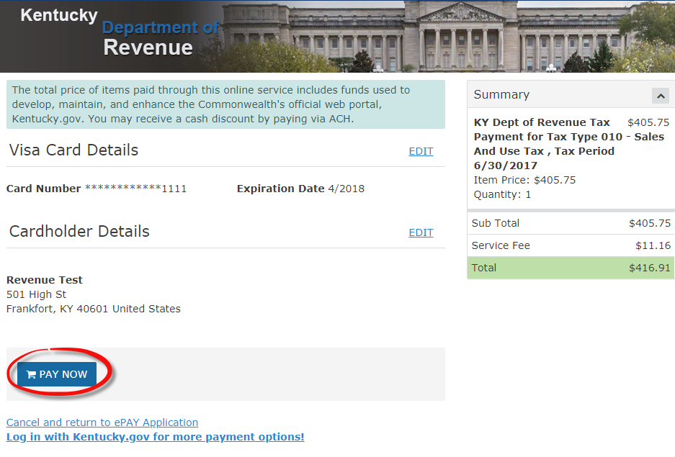

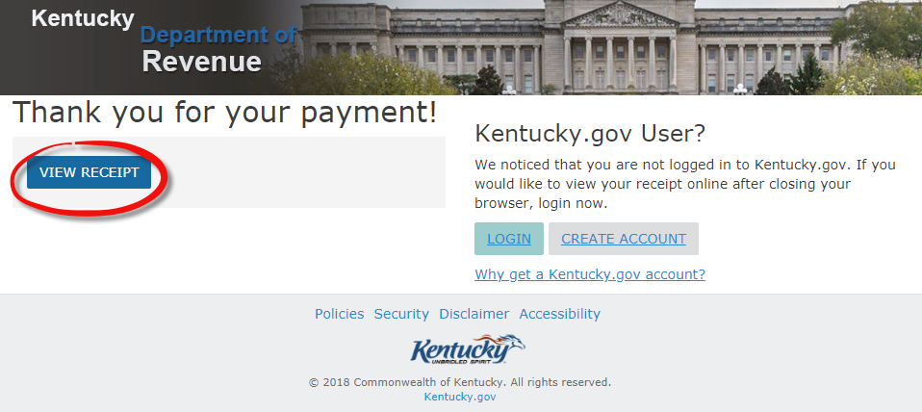
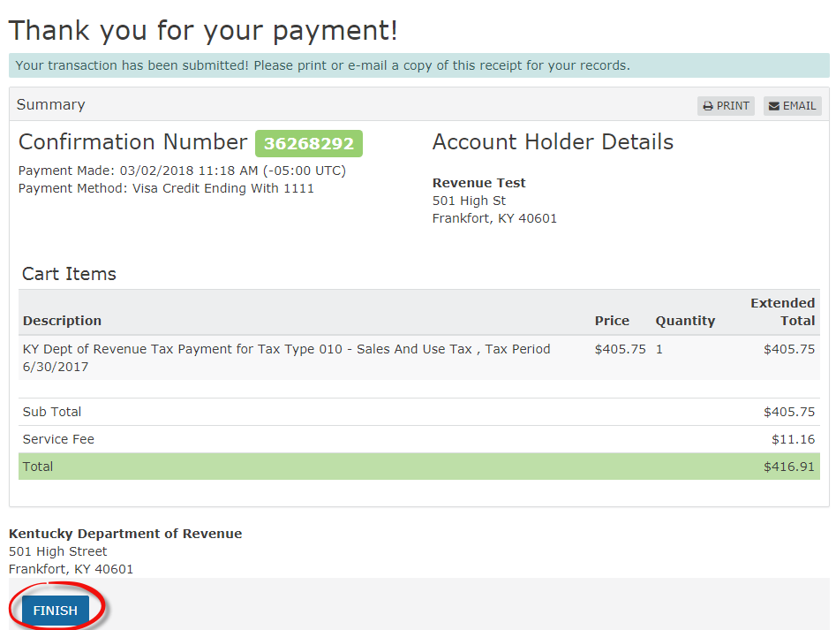

View and Print:
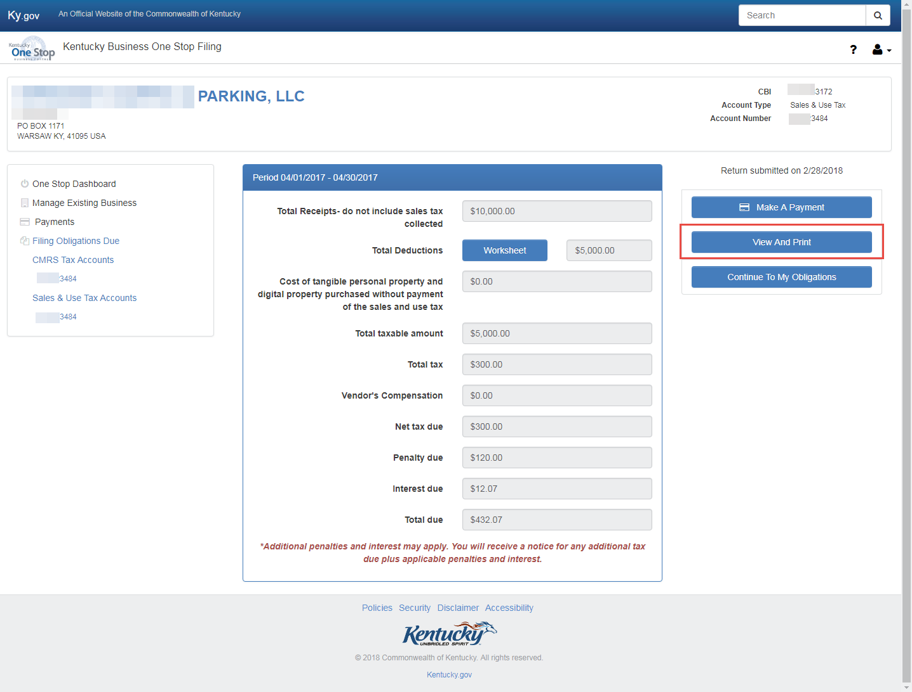

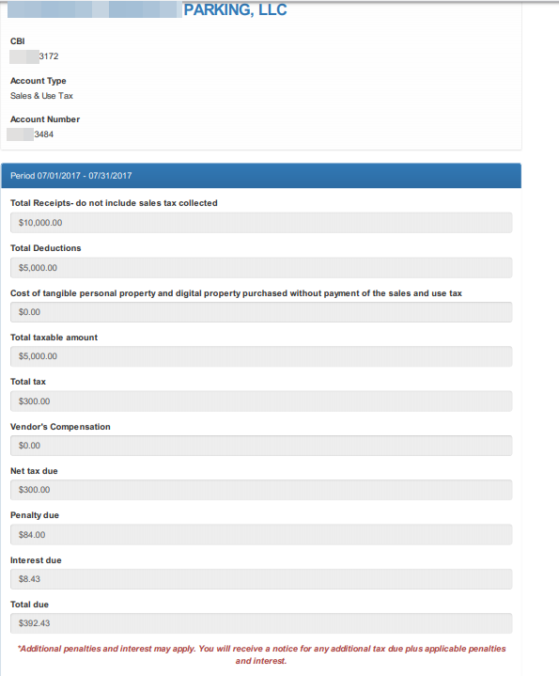

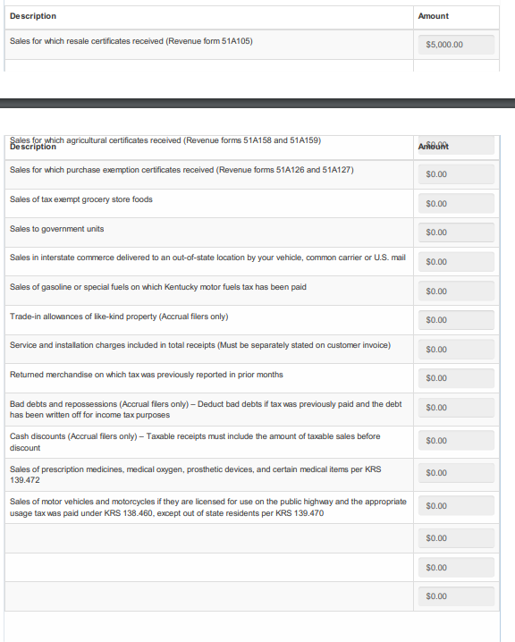

Continue to my obligations:
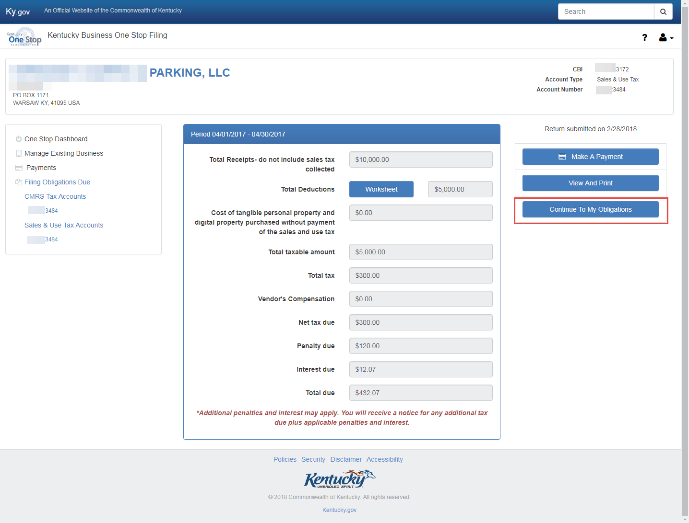

Clicking on Continue To My Obligations takes the user back to where they can file additional tax returns.
Click on Manage Existing Business to go back to the business information page, or click on the One Stop Dashboard link to take you back to the dashboard.

